ICS-202 Project Report

Mohammed Busaleh - 202158210

**Introduction**:

The project simply deals with words from the user to store and traverse on multiple ways and for different purposes.

For this project I decided to go with AVL as the data structure to store the words. The main motivation behind this choice is due to low cost in searching, adding, and deleting. Which are the most used functions in this type of problems.

* Linked list will have a very high cost foreach of these tasks.
* Binary tree will have the problem of randomness in storage.
* BST is good generally but will not function well when the words are in alphabetical order, it will cause an unbalanced skewed tree. Which will result in a complexity similar to that of the linked list.

The need to store the data in some sort of order with the need to balance makes AVL the best choice.

The class has three constructors and five methods, most of them are the usual AVL tree methods such as insert, delete, find, and traverse (used the inorder travers for alphabetical order).

This decision is because we don't need to re-invent the wheel, the typical AVL methods works in very efficient way and with simple edits will fit our project perfectly.

**Problem solving strategies**:

1. **Constructor Operations (`Dictionary()`):**

- Initialize a new AVLTree to store words.

- Print a success message.

2. **Constructor Operations (`Dictionary(String s)`):**

- Initialize a new AVLTree

- insert the provided word (converted to lowercase) into the tree.

- Print a success message.

3. **Constructor Operations (`Dictionary(File infile)`):**

- Initialize a new AVLTree.

- Try opening the specified file. If you can't throw an exception.

- Read each word, convert it to lowercase, and insert it into the AVLTree.

- Print success messages.

4. **Method: `addWord(String s)`:**

- Convert the input word to lowercase.

- Check if the word is already in the AVLTree.

- If not, insert the word into the AVLTree using the regular insertAVL function and print a success message.

- If the word already exists, print a message indicating that the word is already in the dictionary.

5. **Method: `findWord(String s)`:**

- Check if the given word (converted to lowercase) exists in the AVLTree.

- Return true if found, false otherwise.

6. **Method: `deleteWord(String s)`:**

- Delete the specified word (converted to lowercase) from the AVLTree using a regular deleteAVL function.

7. **Method: `findSimilar(String s)`:**

- Convert the input word to lowercase.

- Iterate over all words in the AVLTree (inorder traversal).

- Compare each word with the input word and identify similar words based on a letter difference criterion (<= 1).

- Return a list of similar words.

8. **Method: `writeToFile(String s)`:**

- Check if the given filename contains an extension; if not, add ".txt".

- Create a PrintWriter to write to the specified file or create a new file.

- Get all words from the AVLTree (inorder traversal) and write them to the file.

- Close the PrintWriter.

- Print a success message.

**Test Runs**:

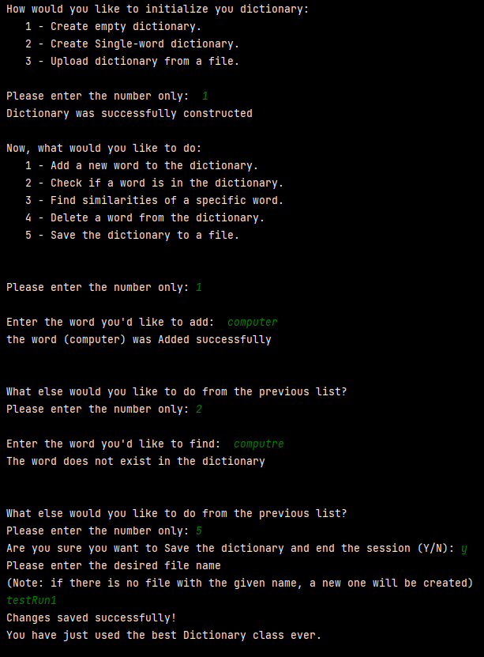Test Run 01:

صورة تحتوي على نص, لقطة شاشة, الخط, رقم

تم إنشاء الوصف تلقائياً

صورة تحتوي على نص, لقطة شاشة, الخط, رقم

تم إنشاء الوصف تلقائياً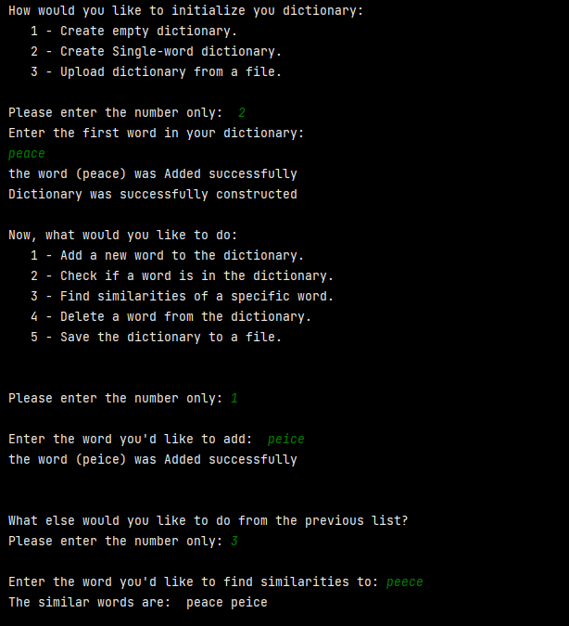صورة تحتوي على نص, لقطة شاشة, الخط

تم إنشاء الوصف تلقائياًTest Run 02:

صورة تحتوي على نص, لقطة شاشة, برمجيات, برامج الوسائط المتعددة

تم إنشاء الوصف تلقائياً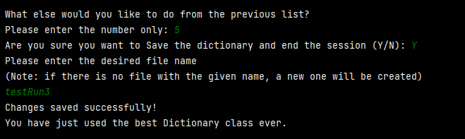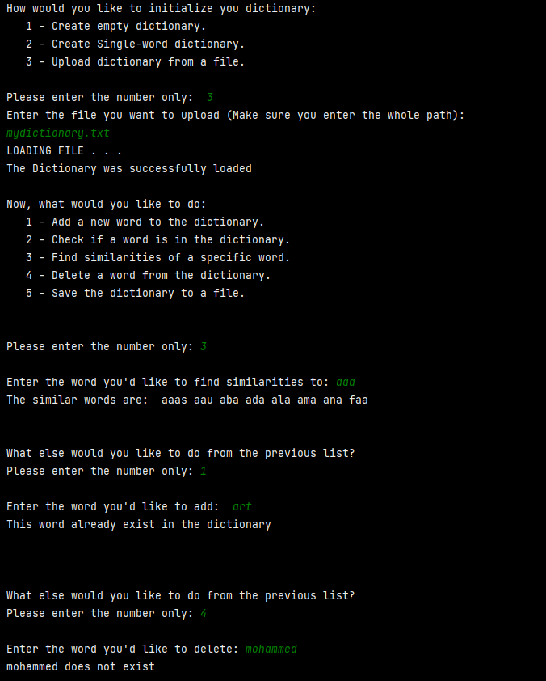Test Run 03:

**Challenges**:

The program is straightforward, no complicated functions were needed.

The hard part was finding the similar words. However, once the idea came to me to use a variable to keep track of the characters difference, it became easy to implement and do.

Another issue here was with the words shorter than each other, which was a logic mistake from my side. The mistake was that I used the length of the key as the cap. However, there are words similar to the key but shorter than it, doing that would cause a *IndexOutOfBounds* exception. I fixed it by taking the minimum of the lengths of the two words as my stopping point rather than always taking the length of the key.

Other than these two issues, the implementation and design was easy, or probably I was too good.